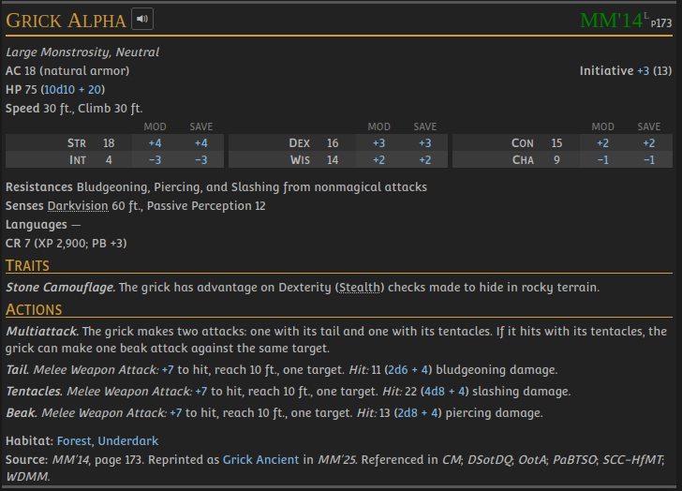
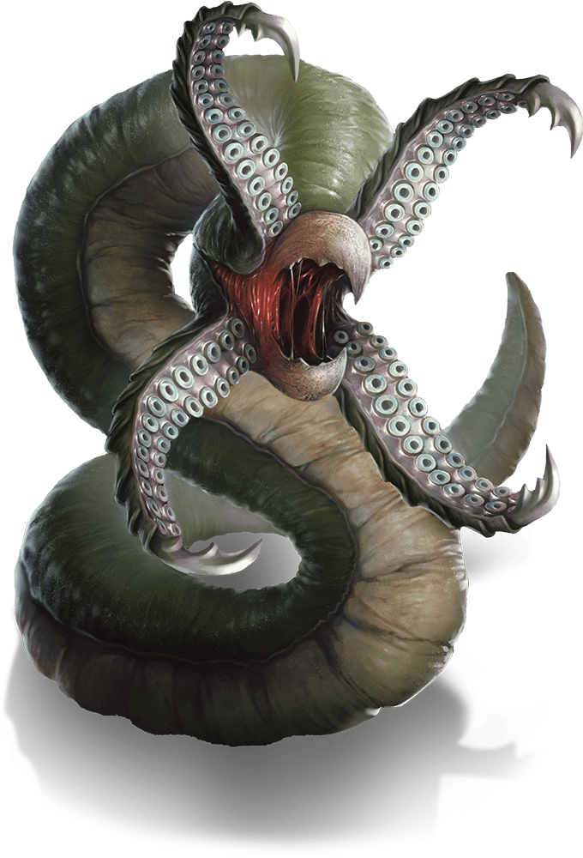
Shooting Stars (Lair Action):
All hostile creatures within 15 ft of the Grick Alpha must succeed on a DC 14 DEX Save or be struck by the monster’s appendages, taking 1d8 piercing damange. The force of the blow is so sudden, any creature who failed the DEX save must also succeed a DC 13 STR Save or fall prone.

